**ALAB 4: Heuristic Evaluation of a Mobile Application**

**1. Enter Your Name and Register Number:**

|  |
| --- |
| **Avatansh Awasthi 1947208** |

**2. Enter the Domain Chosen:**

|  |
| --- |
| **Social Media** |

**3. Enter the Application Chosen:**

|  |
| --- |
| **Instagram** |

1. **Visibility of System Status:   
   Heuristic Violated: No**

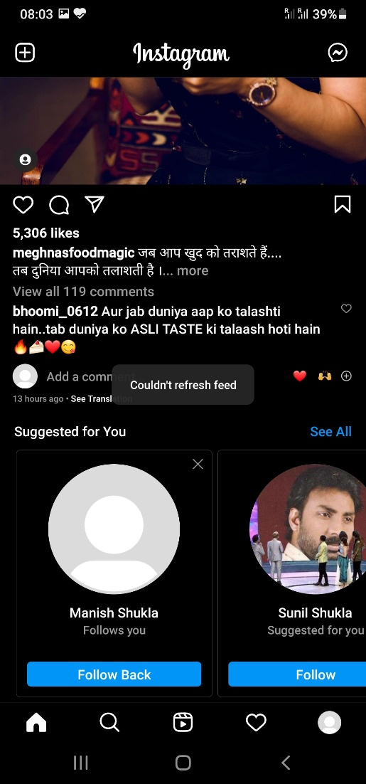 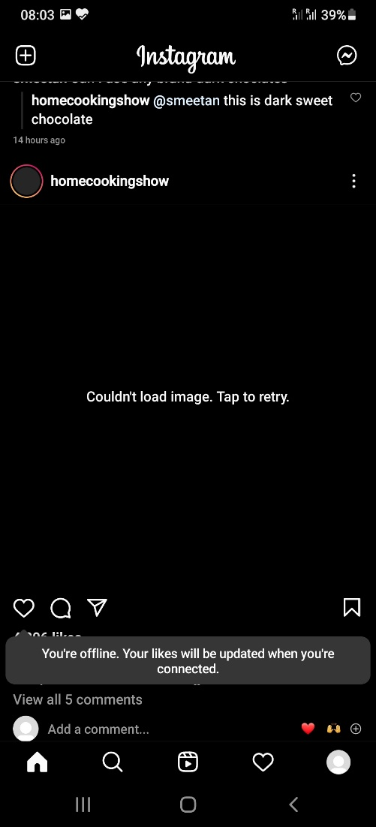 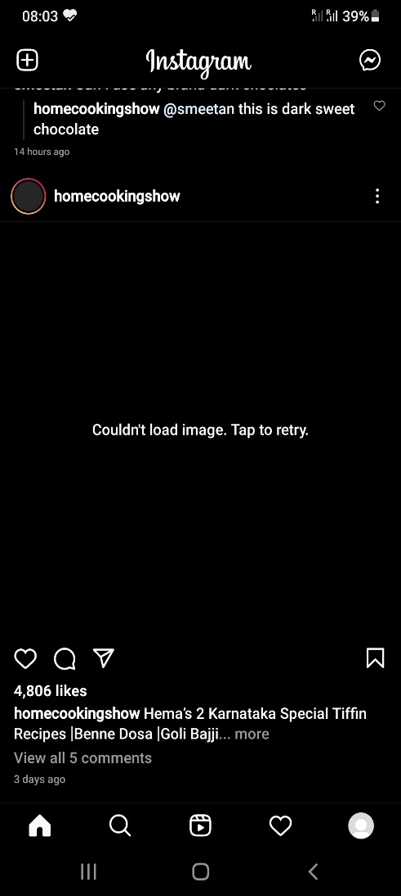

**Explanation**:

|  |
| --- |
| **The application focuses on the system status both online and offline, for online mode if the user refreshes the feed a processing circle informs the user of the updation status of the feed.**  **Also, when offline the user gets prompts on the screen telling, “Couldn’t Refresh feed”, and informs the user that “You’re offline, and so on”, also the feed which did not load due to no internet connectivity says “Couldn’t load image/video, tap to retry”.** |

**2. Match between System and Real World:   
Heuristic Violated: Yes**

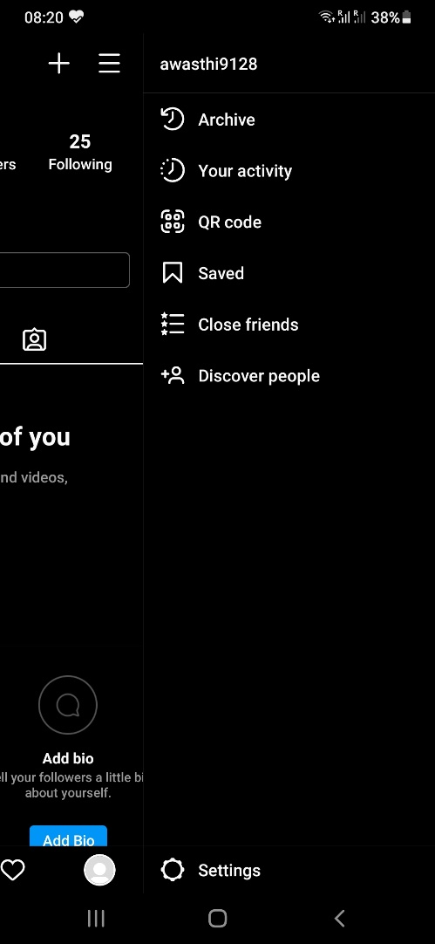

**Explanation**:

|  |
| --- |
| **Terms like “Archive” and “QR code” are technical terms which are not so familiar to the user.**  **Hence, real world conventions are not followed.** |

**3. User Control and Freedom  
Heuristic Violated: No**

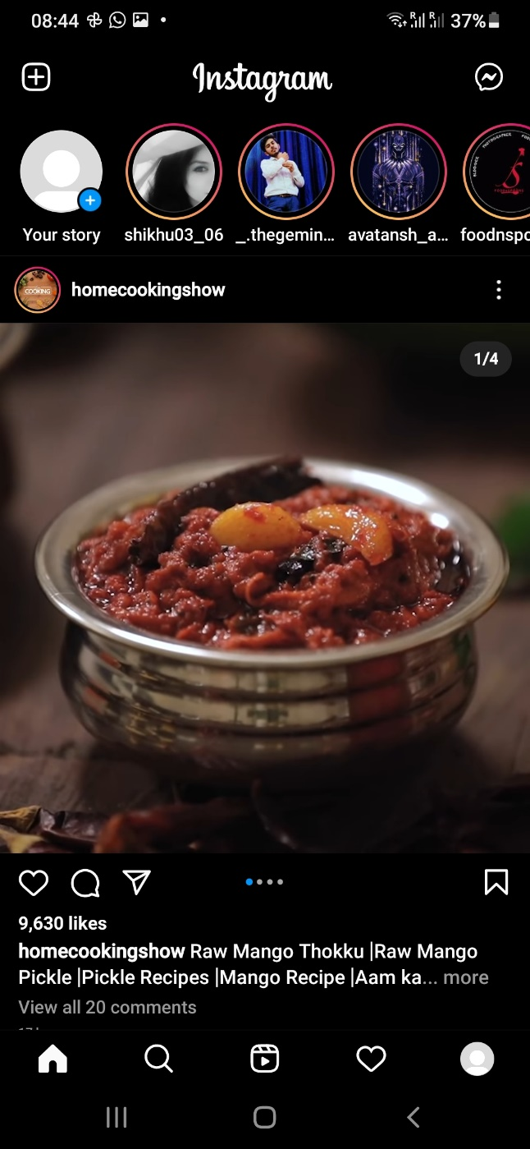 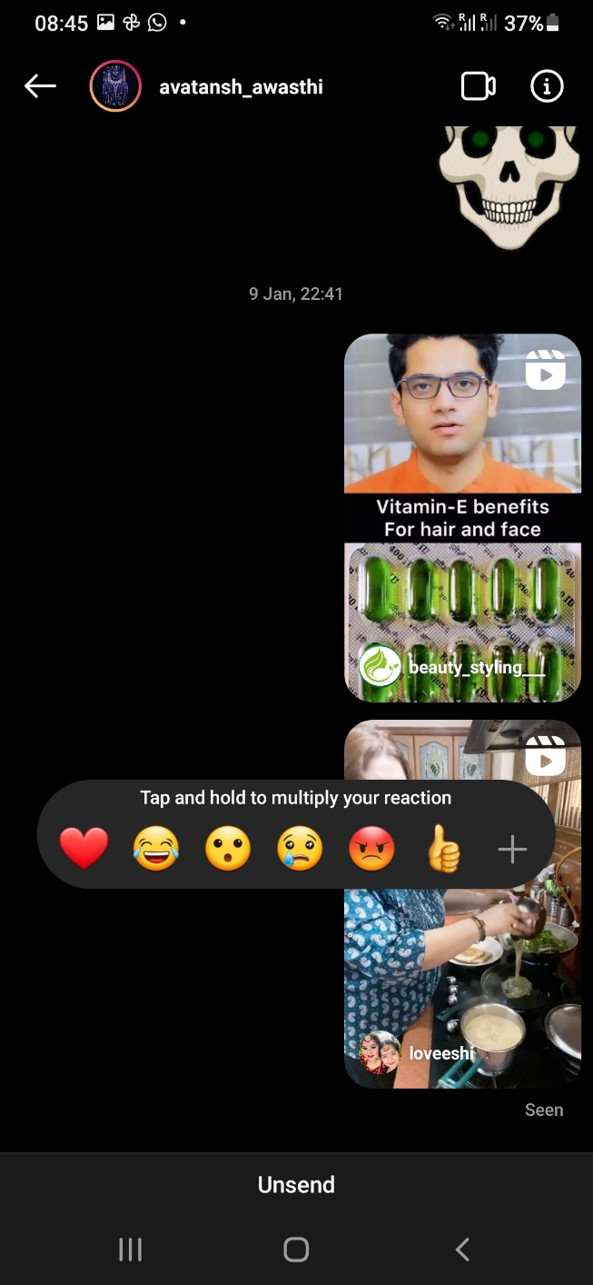

**Explanation**:

|  |
| --- |
| **The user has the freedom to see any amount of feed by refreshing the feed also they can choose any other option such as the reels or to chat.**  **Also, one can unsend the message wrongly sent to anyone.**  **Hence, we can say that the user has the full control of the application and has the freedom to choose and do anything one desires.** |

**4. Consistency and Standards  
Heuristic Violated: No**



**Explanation**:

|  |
| --- |
| **The application keeps the user profile, search and necessary options at the bottom pane for easy location and accessibility making the application consistent.**  **Also, since the social media application has chat window on the right pane of the feed and camera on the left this app also follows the same standard.** |

**5. Error Prevention  
Heuristic Violated: No**

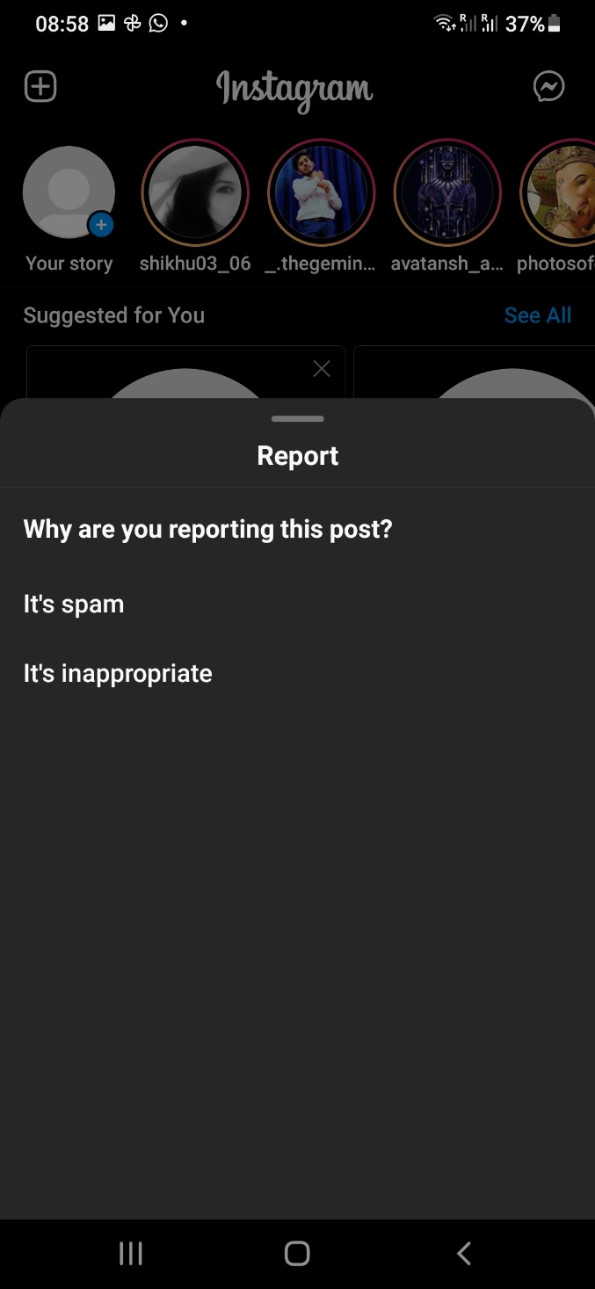 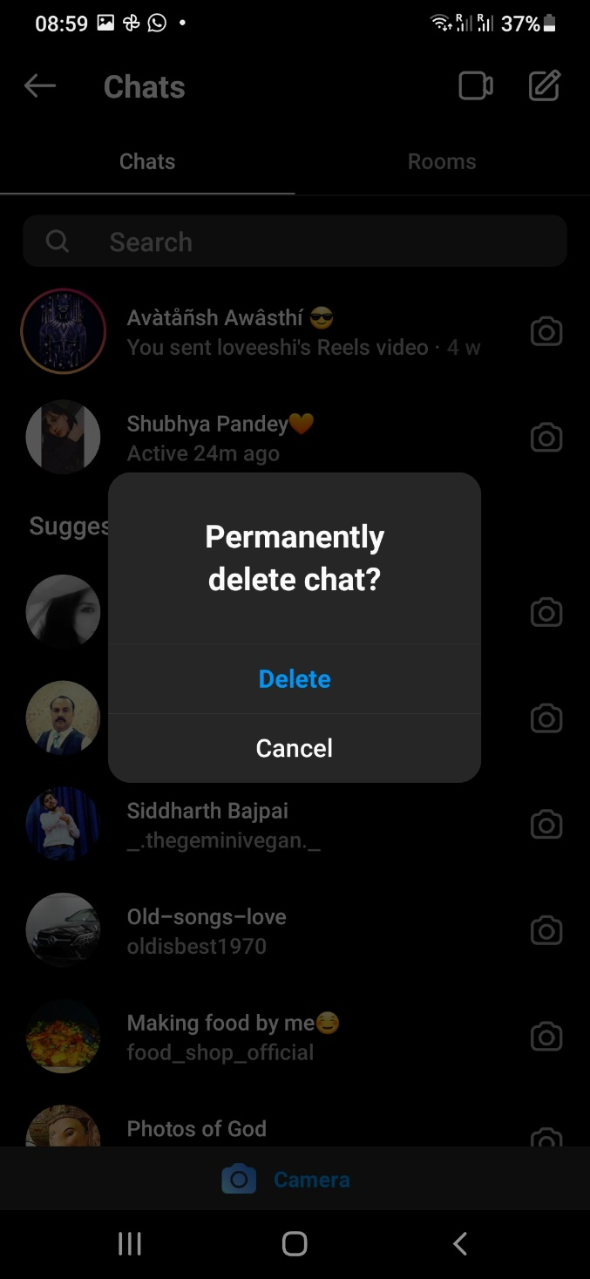

**Explanation**:

|  |
| --- |
| **Whenever the user tries to do something unusual like reporting or deleting the chat the application prompts the user again whether he wants to continue or cancel the operation in order to prevent unknowingly errors committed by the user.** |

**6. Recognition rather than recall  
Heuristic Violated: No**

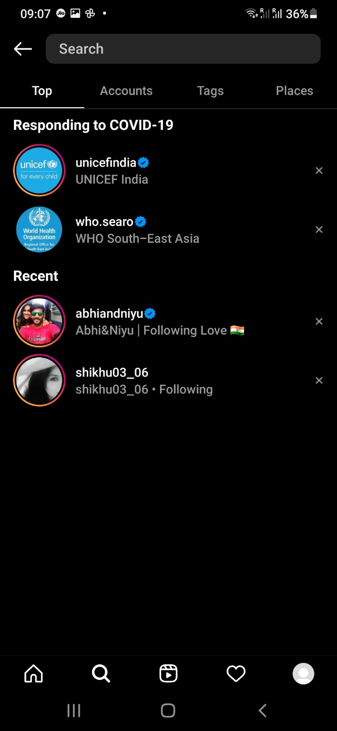

**Explanation**:

|  |
| --- |
| **The application minimizes the memory load from the user by keeping track of previously searched contacts or frequently/recently searched names by the user saving the search effort and time.** |

**7. Flexibility and efficiency of use**  
**Heuristic Violated: No**

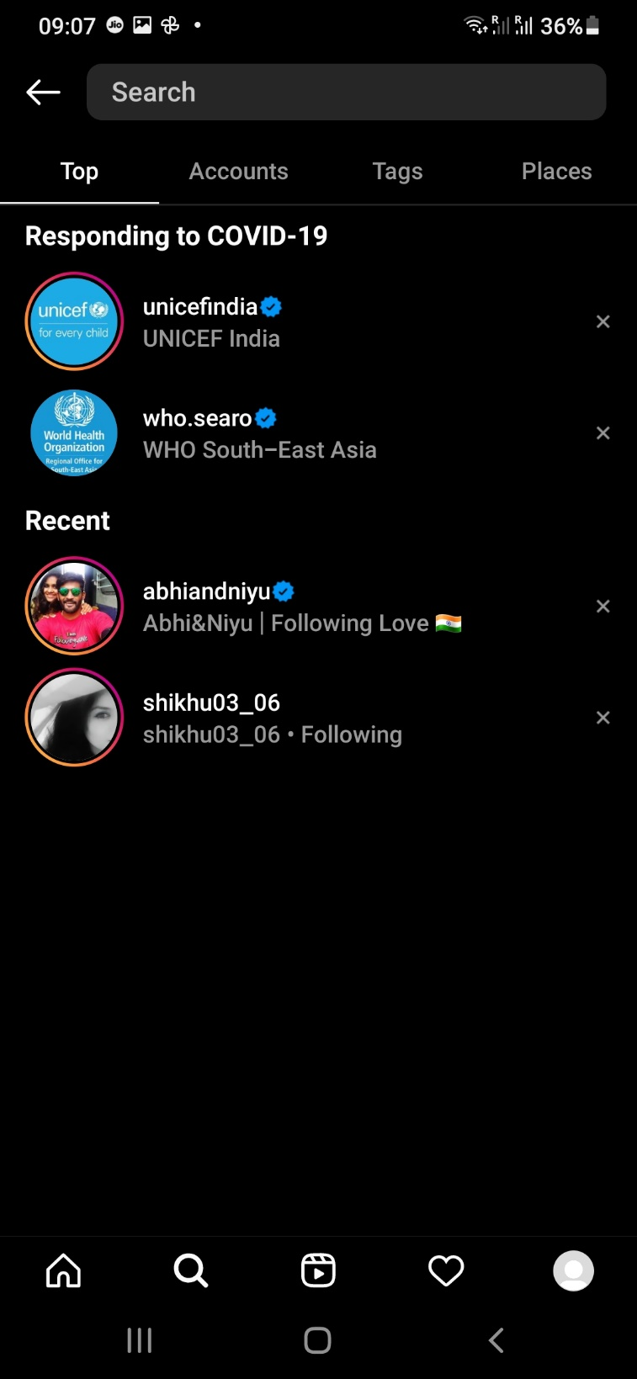

**Explanation**:

|  |
| --- |
| **Since, the application provides the flexibility to choose and make a search in the specific category we can say the application uses the search feature efficiently.** |

**8. Aesthetic and minimalist design**  
**Heuristic Violated: No**



**Explanation**:

|  |
| --- |
| **As we can see on the home or the landing page, only the required or adequate amount of information is being displayed giving us a minimalistic design, also since the application has no in between unnecessary pop up of ads makes the application clutter free and aesthetic.** |

**9. Help users recognize, diagnose, and recover from errors**

**Heuristic Violated: No**

  

**Explanation**:

|  |
| --- |
| **As we can see here the application clearly diagnoses that the user is offline and suggests that his / her data will be loaded one the connection is established or one is again online, also it helps the user to recover from errors by giving useful and helpful instructions like tap to reload and try to reconnect etc.** |

**10. Help and documentation**

**Heuristic Violated: No**

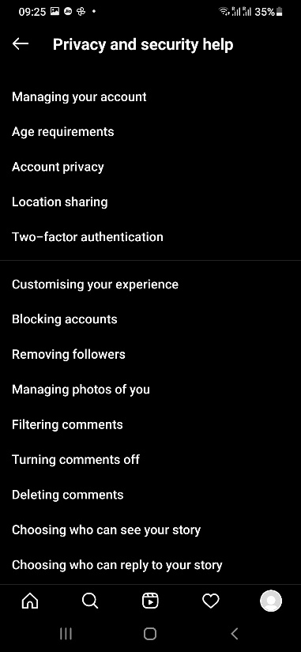 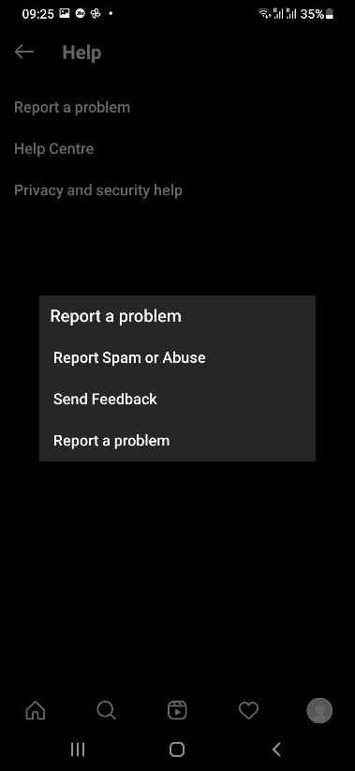 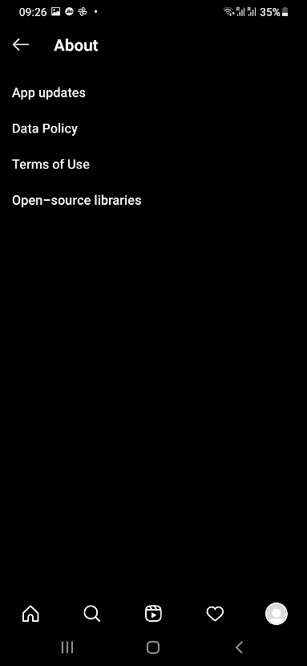 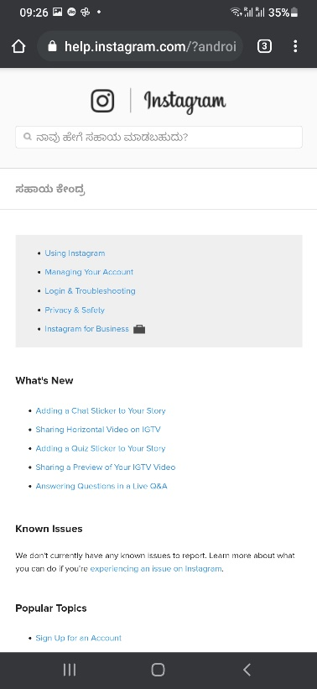

**Explanation**:

|  |
| --- |
| **The application provides more than enough amount of help in various fields of help that may be required by the user also it has a dedicated help center from where you can proceed further for help of any kind.**  **Also, the application has sufficient amount of documentation to support and emphasize their work and the product i.e. the application itself.** |

**\*\*\*\*\*\*\*\*\*\*\*\*\*\***